***Experiment 2***

**Aim:** Use Hadoop to explore large-scale datasets stored in the Hadoop Distributed File System (HDFS).

***Directory:***

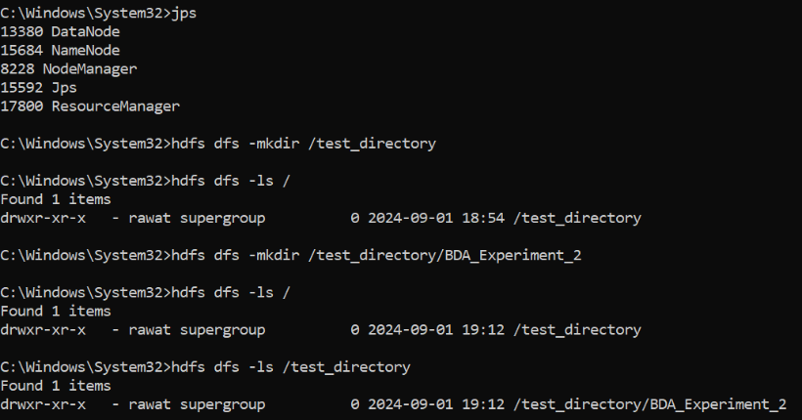

***Fig 1: Making Directory***

***File Transfer:***

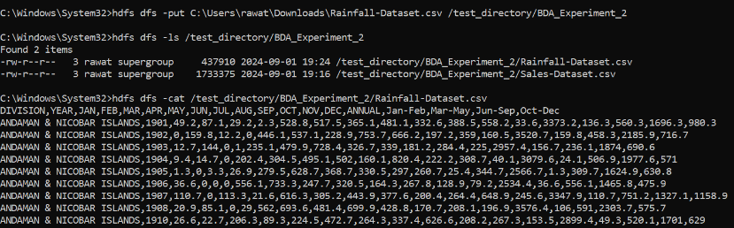

***Fig 2: Transferring Files and File Operations***